Clinic Appointment Efficiency Analysis:

Analysis of the Appointment efficiency of HealthFirst Clinic

By: Ken K. Macharia, Healthcare Data Analyst.

Tools used: Google Sheets.

# Executive Summary:

This project analyzes data from fictitious HealthFirst clinic appointments to optimize the appointment and consultation process, and to explore ways to optimize patient management in the facility. Key findings include: lack of reminders leading to missed appointments,

This project analyzes appointment efficiency at theHealthFirst Clinic using a dataset of 500 patient appointment records. The objective was to evaluate attendance patterns, identify causes of missed appointments, and offer recommendations to optimize clinic scheduling and patient management. Using Google Sheets, key metrics such as attendance rates, appointment types, clinician workload, and duration discrepancies were explored.

The clinic’s appointment attendance ratio stands at **85.4%**, falling short of the **95% target**, with most missed appointments attributed to patients **forgetting** or giving **no reason**. The **60–70 year** age group had the highest no-show rate, and **male patients** were more likely to miss appointments. Clinician analysis revealed that **Dr. A** had the heaviest workload, while **Dr. C** had the **lowest discrepancy rate** in scheduled vs. actual appointment duration, suggesting consistent time management.

Discrepancies were most common between **10:00 AM and 1:00 PM**, and on **Sundays**, possibly due to operational fatigue. Missed appointments were highest on **Wednesdays**, indicating a possible scheduling bottleneck.

Based on these findings, targeted recommendations include implementing **automated reminder systems**, redistributing **clinician workloads**, and adjusting scheduling strategies to reduce **midday and weekend strain**. These insights offer actionable paths to improve clinic efficiency and enhance patient follow-through.

# Project Overview:

Objective: To understand the clinical appointment procedure, no-show rates, causes of missed appointments.

Dataset: 500 simulated patient records containing: AppointmentID, PatientID, Date, Time, Gender, Age, Clinician, Scheduled duration, Actual duration, Attended.

Tools used: Google sheets.

Key Questions: What is the appointment attendance ratio? What are the main causes of missed attendance? What can be done to improve the appointment attendance ratio?

# Key Insights:

1. The clinic has a relatively high attendance ratio of 85.4%, but the target is above 95%
2. The main reasons for missing appointments included: forgetting, no reason, suggesting the need for regular reminders to the patients.
3. The age bracket with the most missed appointments is the 60-70 year age bracket. This calls for more reminders and possible involvement of guardians or other proxies for the reminders.
4. Dr. C had the lowest discrepancy rate of 9.5% compared to the rest of around 12 to 13%. He needs to be commended and benchmarked.
5. Dr. A has the highest workload, while Nurse has the least amount of appointments.

# Methods and Skills Demonstrated:

Data cleaning

Descriptive statistics

Pivot Tables

Conditional formatting

Data storytelling

# Analysis:

#### Demographic Analysis:

Total number of booked appointment visits: 500

Number of actual attended visits: 427 ( 85%)

Number of missed visits: 73 (15%)

Gender distribution:

Male scheduled appointments: 212 (49.8%)

Female scheduled appointments: 215 (50.2%)

Age distribution: 60-70 yr age group noted to have the most missed appointments (see attached histogram in the appendix)

#### Appointments Analysis:

85.4% (427) of scheduled appointments were done. 14.6% (73)were missed.

Male missed appointments: 37 (50.68%)

Female missed appointments: 36 (49.32%)

Scheduled appointments by type:

Consultations: 291 (58.2%)

Follow ups: 161 (32.2%)

Emergencies:48 (9.6%)

Missed appointments by type:

Consultations: 38 (13.06% of all consultations.)

Follow ups: 25 ( 15.53% of all follow ups.)

Emergencies: 10 (20.83% of all emergencies.)

Missed appointments by ratio

Consultations: 52% of all missed appointments.

Follow ups: 34.25% of all missed appointments.

Emergencies: 13.70% of all missed appointments.

More than half of missed appointments were consultations.

Reasons for missing appointments include:

Forgot: 27.4%

No reason: 23.29%

Sick: 19.18%

Transport: 10.96%

Weather: 19.18%

Most of the forgotten missed appointments were from male patients.

Most missed appointments were on Wednesday, suggesting a need to reduce the number of booked appointments on Wednesdays.

#### Clinician Analysis:

Clinician Workload:

Dr. A: 121 appointments seen.

Dr. B: 109 appointments seen.

Dr. C:105 appointments seen.

Nurse D: 92 appointments seen.

Dr. A had the most workload compared to Nurse D who had the least. Restaffing should be done to reduce overall burden.

All clinicians had an average time of 21.49 minutes per patient. No clinician was far off from this average, indicating similar working times.

#### Discrepancies Analysis:

The most number of appointments with significant discrepancies (an absolute difference of 8 minutes or more between the scheduled duration and the actual duration )were on Sunday (10).

Clinician discrepancy ratio:

Dr. A: 12.4%.

Dr. B: 12.84%.

Dr. C:9.52%.

Nurse D: 13.04%.

Despite Nurse D’s fewest appointments, he had the highest ratio of discrepancies.

Dr. C had the lowest at 9.52%.

Most of the discrepancies were between 10:00 and 13:00 hours, suggesting the need to reduce the number of appointments during this period.

# Recommendations:

1. More than half of missed appointments were consultations, indicating the need for more reminders for the booked consultations.
2. The most number of appointments with significant discrepancies were on Sunday (10) suggesting worker fatigue or other factors such as delays in patient processing leading to the delays. Scheduling should be done such that there are fewer appointments on Sunday.
3. Most of the discrepancies were between 10:00 and 13:00 hours, suggesting the need to reduce the number of appointments during this period.
4. All clinicians had an average time of 21.49 minutes per patient. No clinician was far off from this average, indicating similar working times.
5. Dr. A had the most workload compared to Nurse D who had the least. Restaffing should be done to reduce overall burden.
6. Forgetting and lack of stated reasons accounted for over 50% of missed appointments, which suggests that behavioral or motivational factors may play a role.
7. The age bracket with the highest missed appointments are the 60-70. A way to reduce the missing of appointments would be having multiple reminders, and where possible, involve their next of kin or proxies.
8. Most of the missed appointments were from male patients, suggesting the need for more reminders and more actions for this demographic.
9. Dr. C had the least amount of discrepancies in his work. He should be commended and benchmarked.

# Reflections:

Through this project, I was able to master the Google Sheets skills such as filtering, using conditional formatting, and pivot tables. I was able to demonstrate my skills in various visualization tools in Google Sheets. I have also been able to hone my skills in data analysis and operational insight and being able to offer actionable recommendations.

# Visuals and Tables:

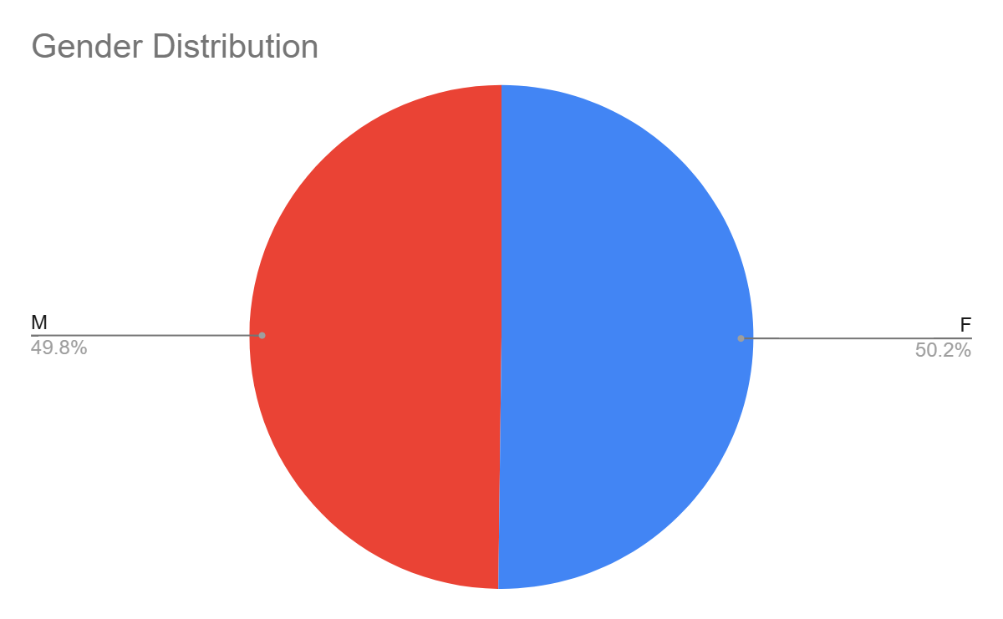

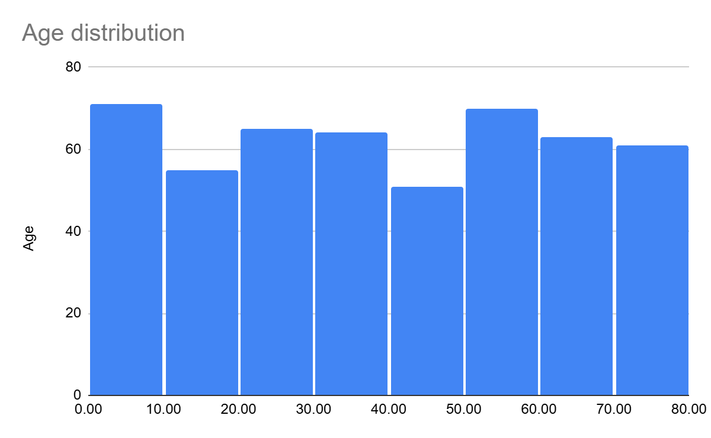

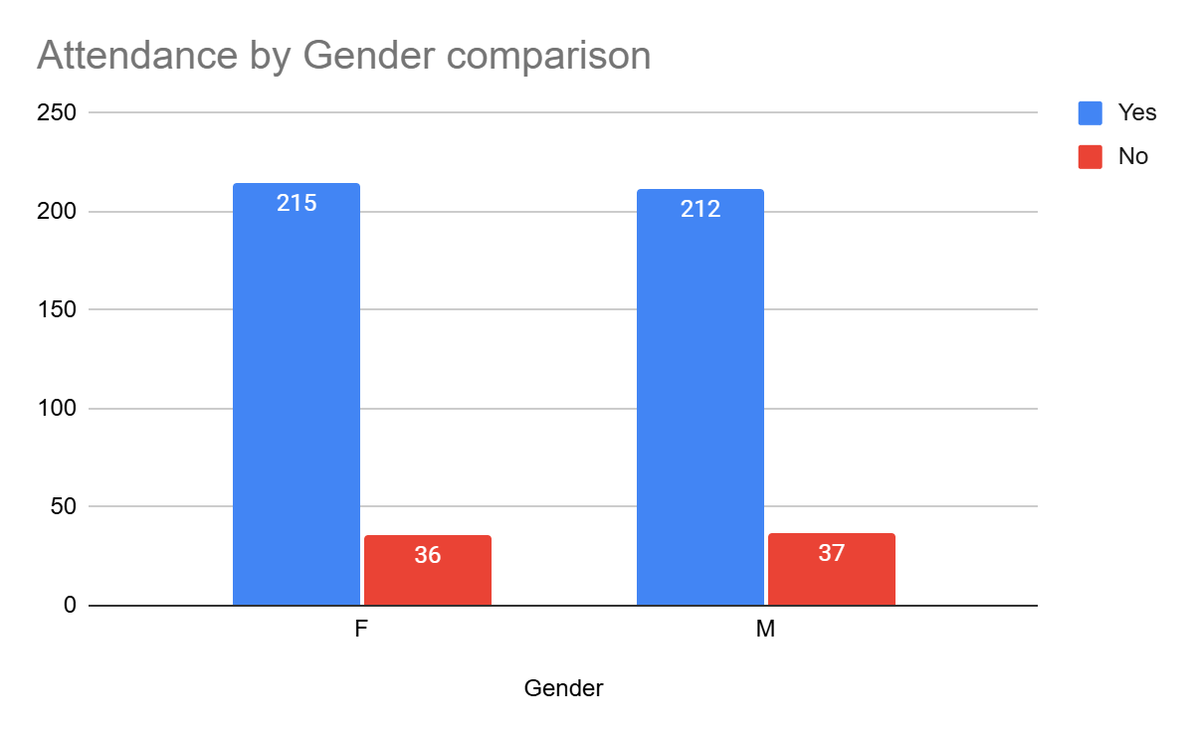

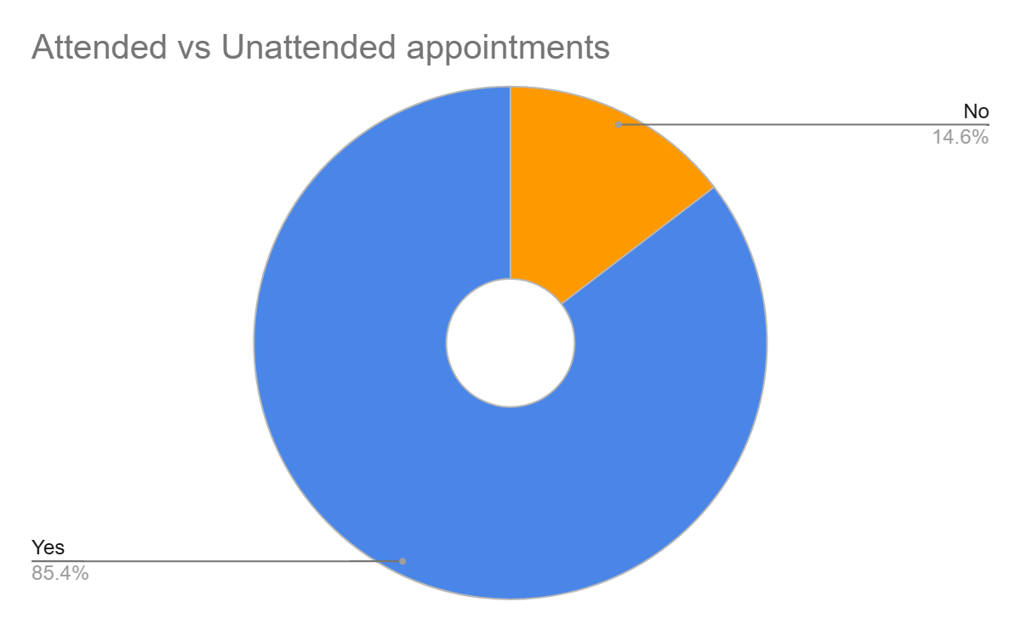

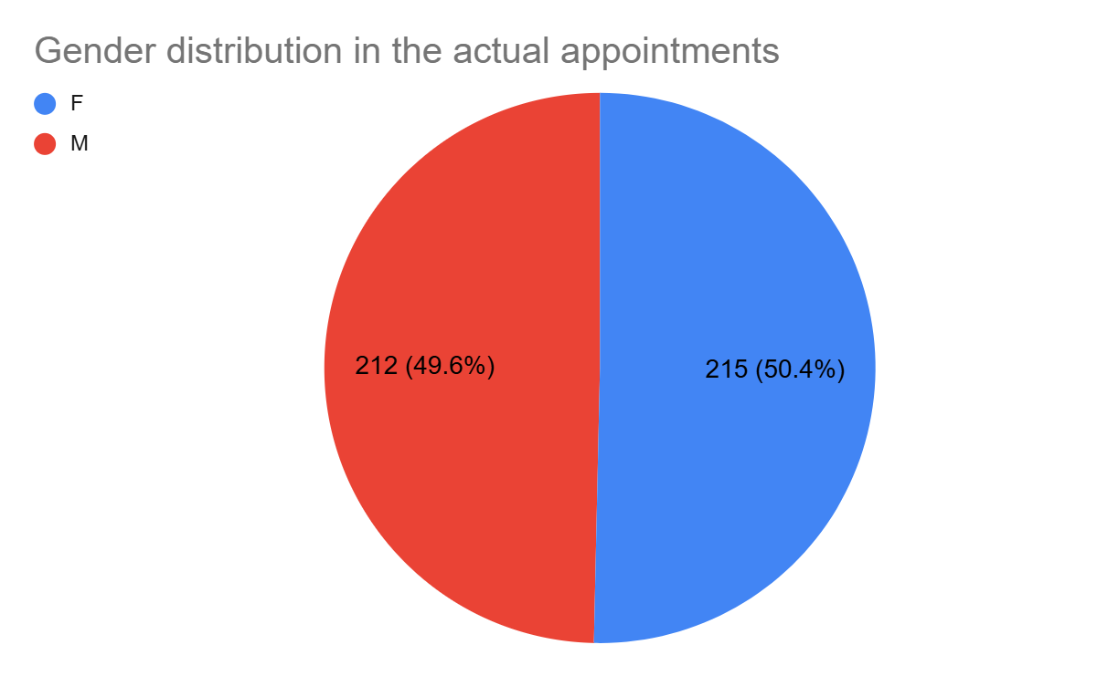

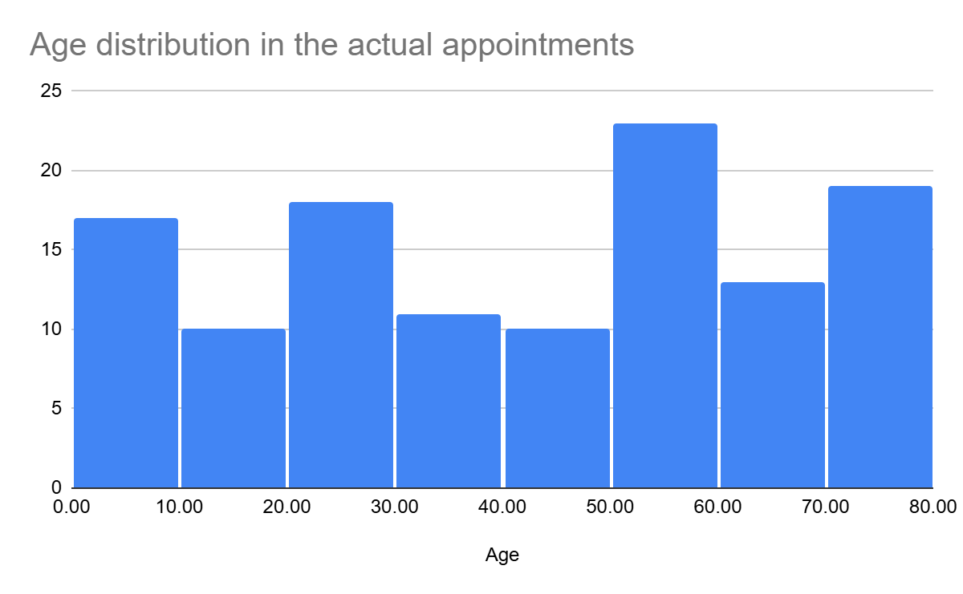

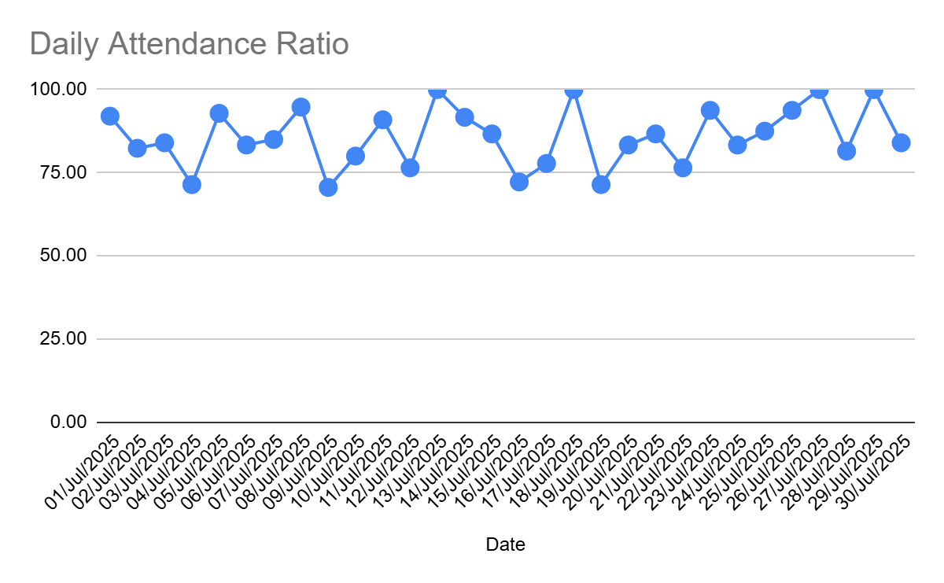

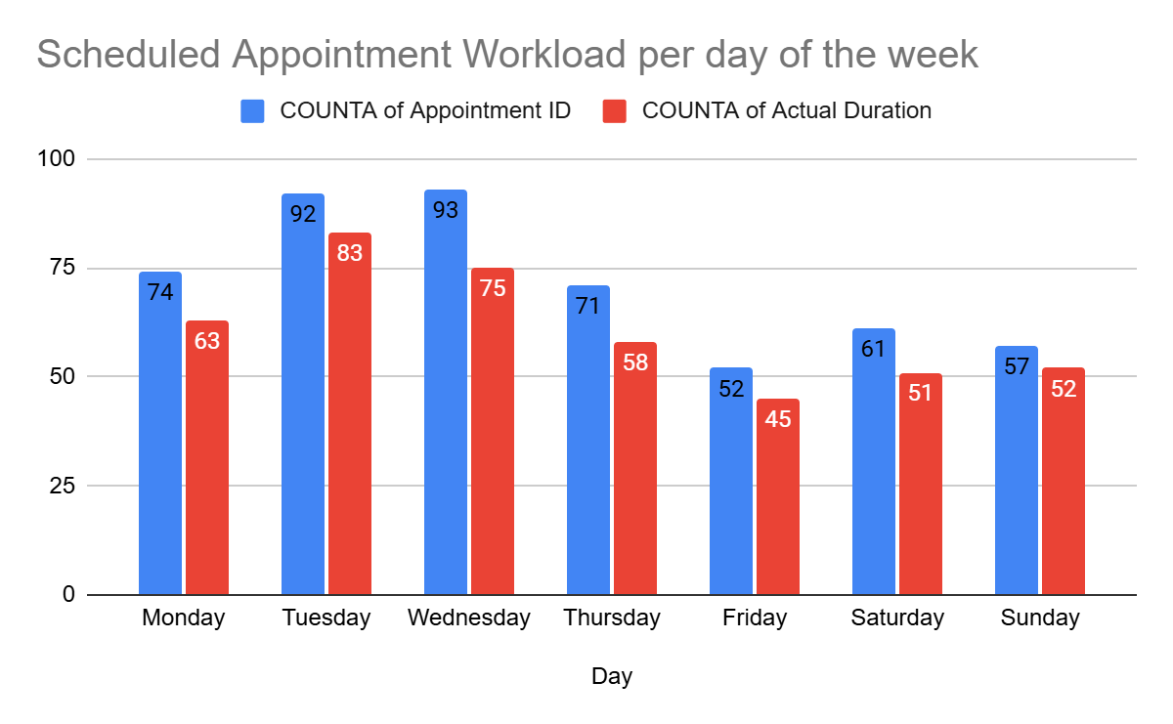

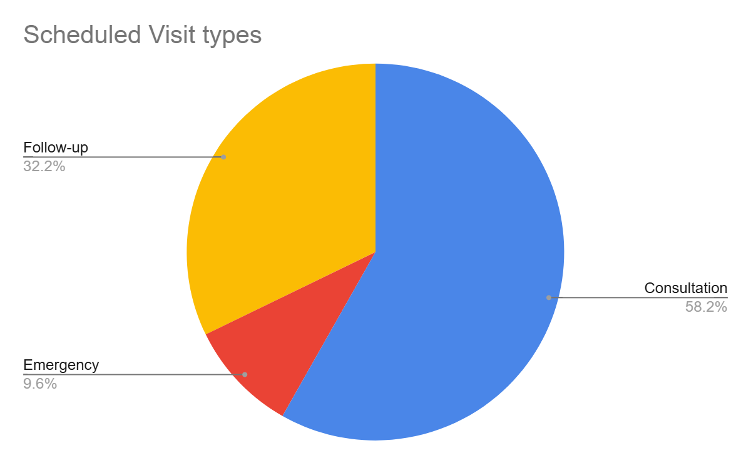

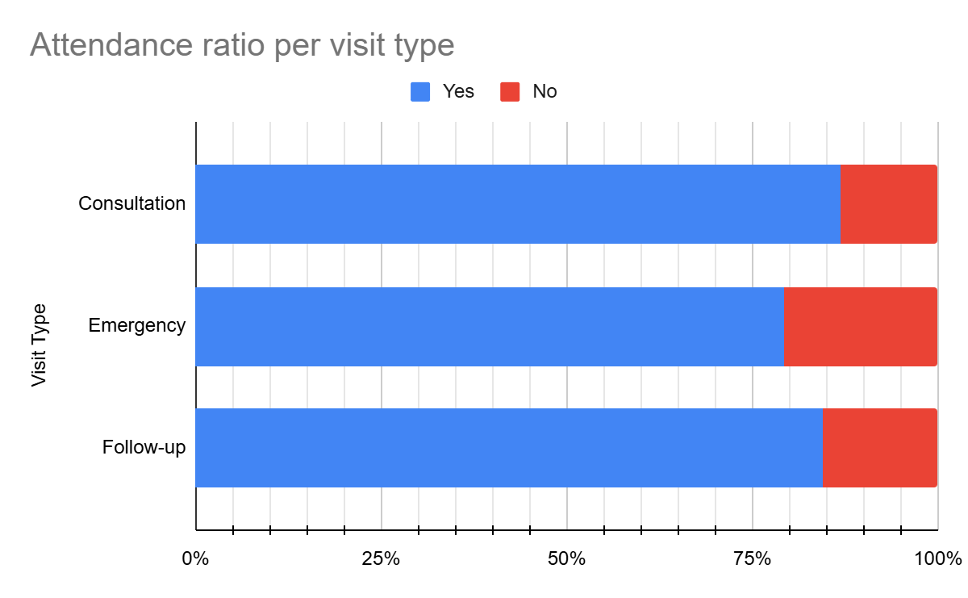

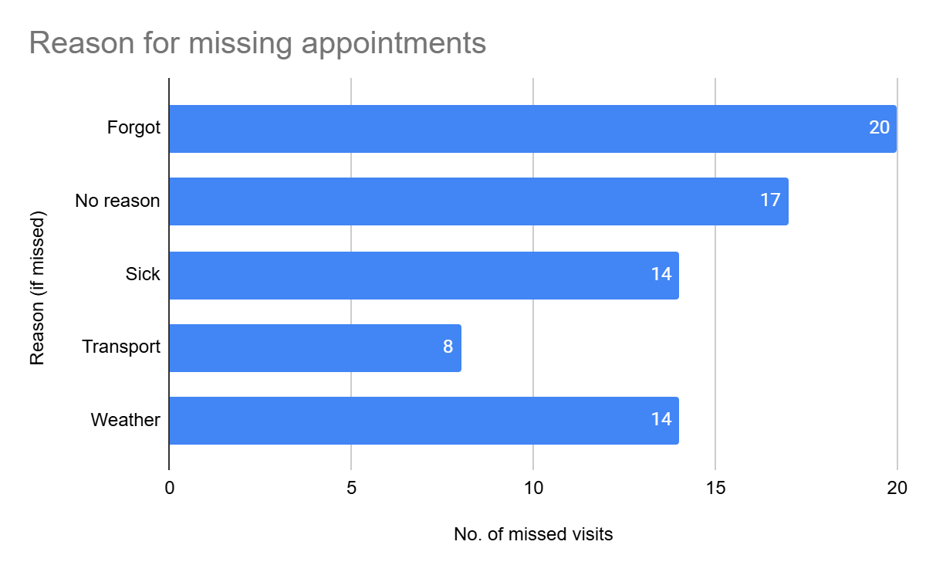

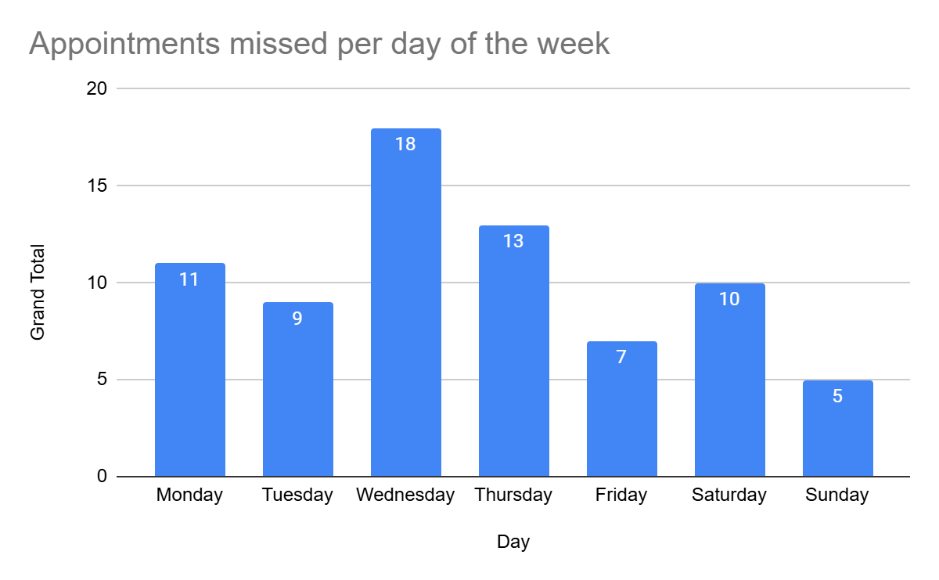

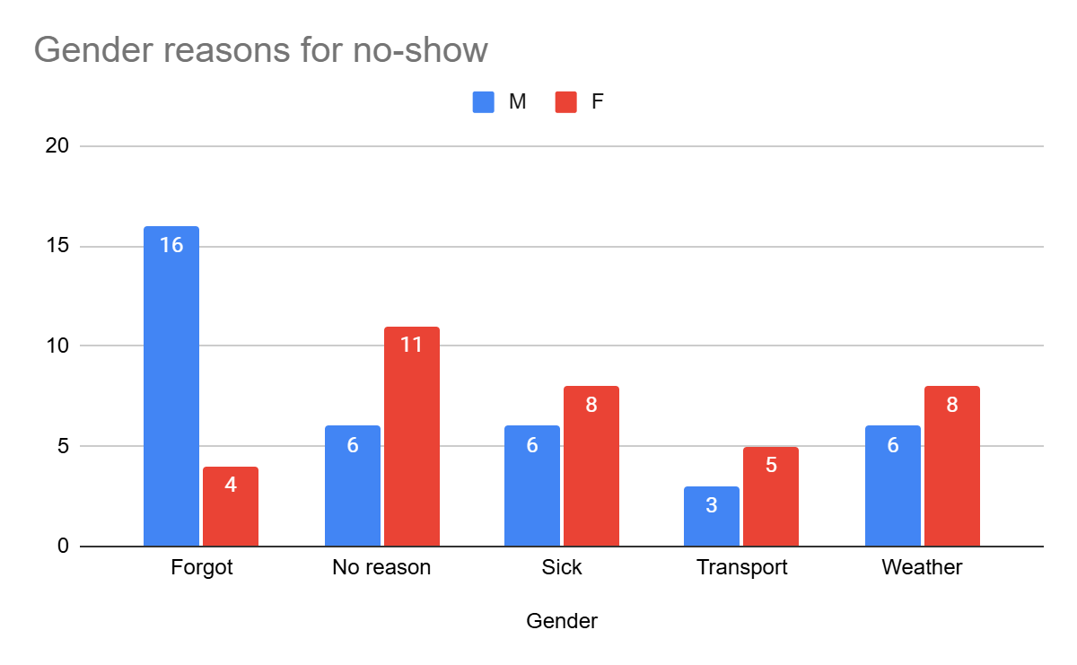

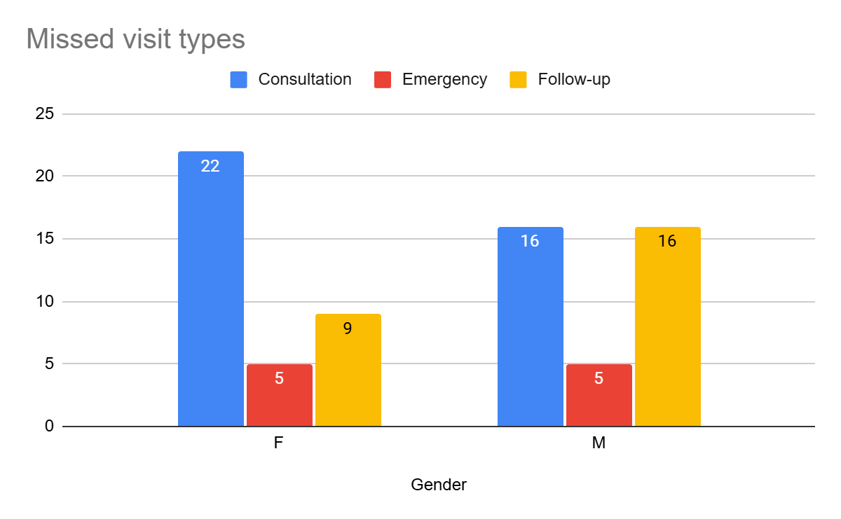

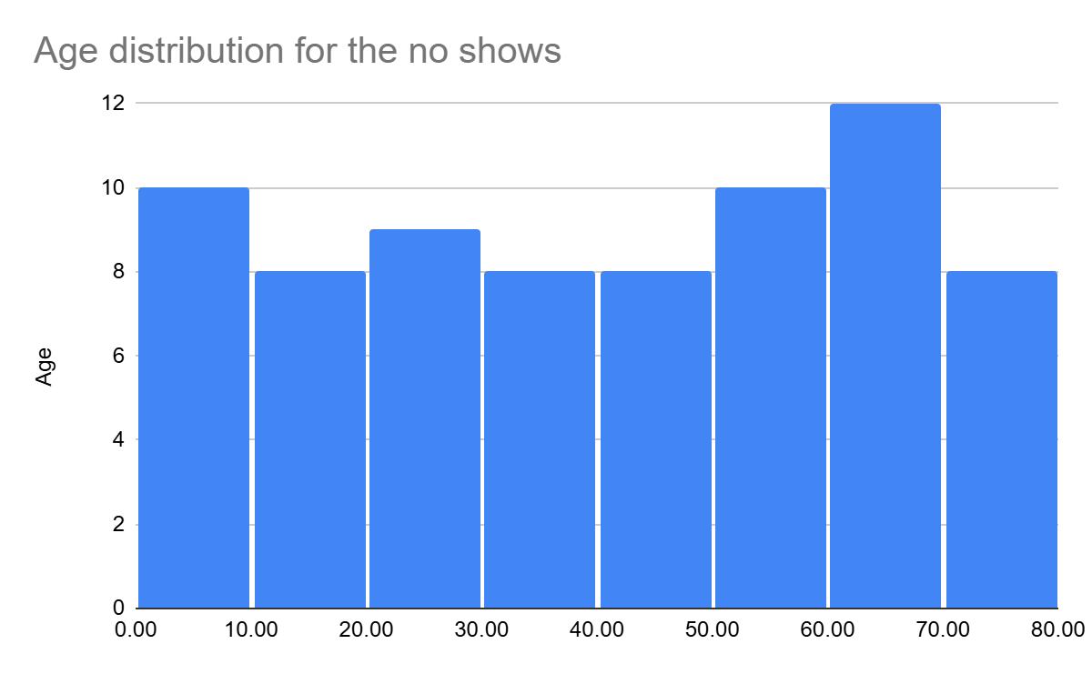

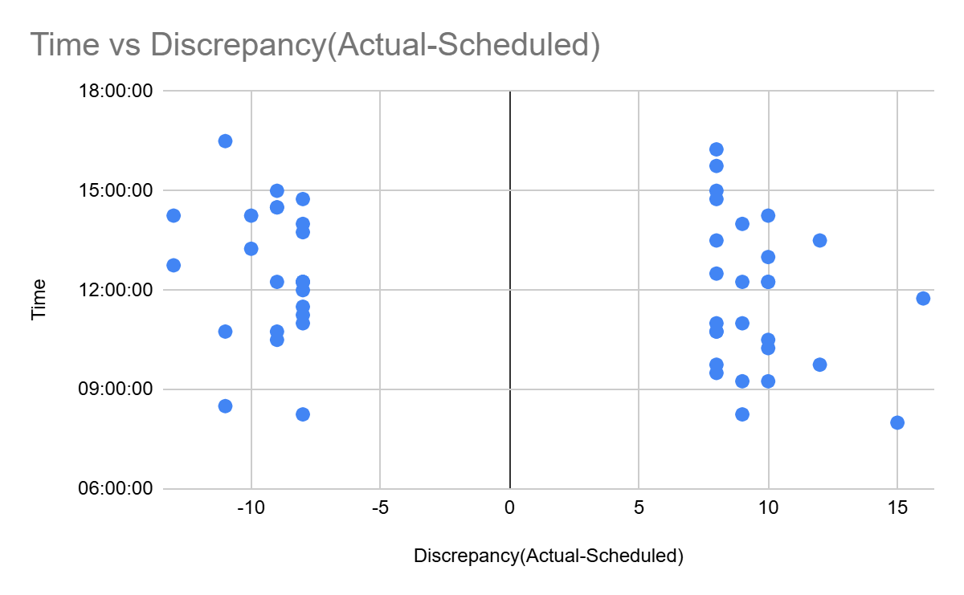

# Supplementary materials:

Github repo: https://github.com/K3nnKM/Clinic-Appointment-Efficiency